Tú chủ đề 5,7

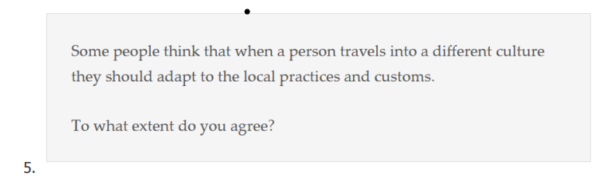

Agree

1. Adapting to local practices allows travelers to immerse themselves fully in the cultural experience, leading to a deeper understanding and appreciation of the host culture.
2. When travelers adapt to local practices, they contribute to the preservation and promotion of cultural diversity, recognizing the value of different customs and traditions around the world.

Disagree

A balanced approach to cultural exchange involves a mutual learning process, where both travelers and locals have the opportunity to share and learn from each other's practices and customs, promoting mutual understanding and appreciation.

1. Each person brings a unique perspective to cultural interactions, and preserving one's own practices and customs while traveling can contribute to a more enriching and diverse exchange of ideas and experiences.



Advantage:

1. The focus on generating revenue from cultural traditions can create a dependency on tourism, making these traditions vulnerable to fluctuations in tourist demand and potentially causing neglect or loss of other important aspects of the culture.
2. When cultural traditions are transformed into profit-driven attractions, there is a risk of losing their authenticity and cultural significance, as they may be distorted or simplified to cater to tourist preferences.

Disadvantages:

1. Commercializing cultural traditions as tourist attractions can generate revenue that can be reinvested in the preservation, restoration, and promotion of these traditions, ensuring their long-term sustainability.
2. Opening cultural traditions to tourists can create opportunities for cultural exchange and dialogue, fostering mutual understanding, appreciation, and respect between different cultures.

* Chủ đề 4: **On one hand, some people think that tourism should not be allowed in some areas to protect local culture.**
* People are afraid that tourism can result in environmental degradation in some areas. Tourists may throw away litter or cause damage to local heritage.
* Visitors can lead to the commercialization and distortion of local cultures. Traditional practices and customs may be altered or performed solely for the entertainment of tourists.
* **On the other hand, others claim that there will always be change from time to time and there won’t be any benefits in prohibiting tourism.**
* Tourism often serves as a significant source of income for local communities. Tourism can bring about huge development to areas as many facilities are built and this also creates more job opportunities for local people.
* Tourism can facilitate cultural exchange, fostering understanding and appreciation between visitors and local residents. Tourists can learn a lot about the locals and learn to respect their customs.
* **In my opinion, while preserving local culture is crucial, prohibiting tourism may not be the best solution. There should be a balanced approach so as to gain benefits from tourism while maintaining cultural values.**